

**MODEL INSTITUTE OF ENGINEERING & TECHNOLOGY, JAMMU**

**REPORT ON: ClickShop – An Online Shopping Bot**

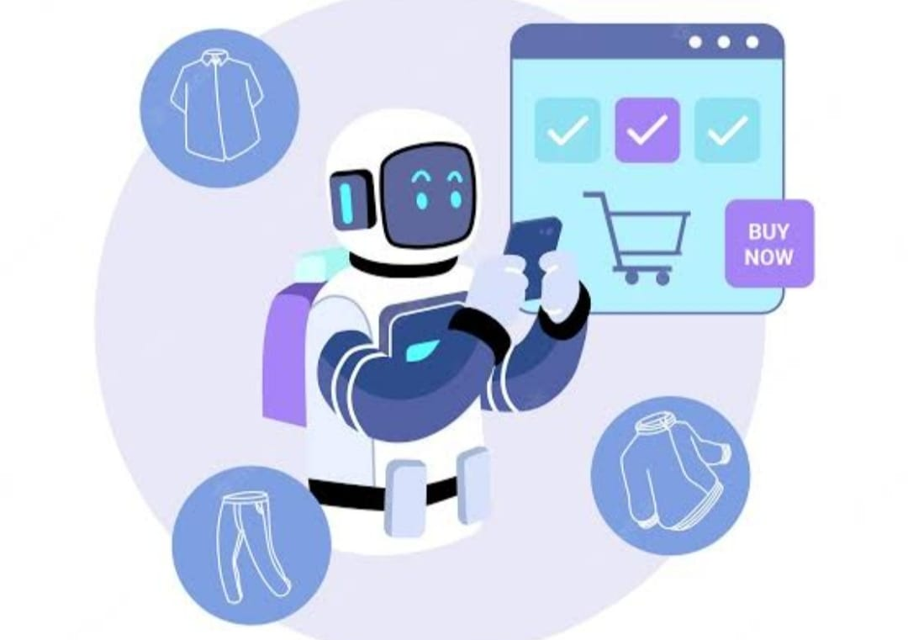

**SUBMITTED TO: Mr. ANIL GUPTA**

**GUNISHA AGGARWAL (2022A1R112)**

**DHRUV SUNDAN (2022A1R118)**

**NIKHIL GUPTA (2022A1R090)**

**SMARTH SACHDEVA (2022A1R116)**

**ACKNOWLEDGEMENT**

I would like to acknowledge and express my sincere gratitude to the following individuals and resources which have played a significant role in the successful completion of the ClickShop project:

I am incredibly grateful to my project supervisor and advisor Mr. Anil Gupta for their unwavering support, guidance, and valuable insights throughout the development of ClickShop. Their expertise and mentorship have been instrumental in shaping the project and ensuring its successful implementation.

I would like to extend my appreciation to UiPath for providing the robot automation platform including UiPath Studio and its activities. The UiPath platform has served as the foundation for the development of ClickShop, enabling seamless automation and data extraction.

I would like to thank the various online resources, tutorials, and forums that have provided insights and best practices for web scraping and data extraction techniques. These resources have been invaluable in helping me understand and implement the necessary functionality in ClickShop.

I am grateful to the individuals who participated in testing the ClickShop system and provided valuable feedback. Their input helped identify and address any issues, ensuring the reliability and functionality of the project.

I would like to acknowledge the developers and contributors of open-source libraries and tools that were utilized in the ClickShop project. Their efforts have provided additional functionality and capabilities, enhancing the overall performance and user experience.

I want to express my appreciation to my peers who have provided support, shared ideas, and engaged in discussions related to the ClickShop project. Their collaboration and feedback have been immensely valuable in refining and improving the system.

Finally, I would like to extend my gratitude to all the unnamed individuals who have contributed to the ClickShop project in any form. Whether through support, inspiration, or encouragement, their contributions have played a vital role in the project's success.

Thank you all for your invaluable contributions and support throughout the development of the ClickShop project.

GUNISHA AGGARWAL

Certificate of Completion

This is to certify that Gunisha Aggarwal has successfully completed the UiPath project titled "ClickShop" as part of their Business Process Automation with RPA Lab. The project demonstrates the ability to design and implement an automated online shopping solution using UiPath Studio.

During the course of this project, Gunisha Aggarwal has displayed a comprehensive understanding of UiPath's automation capabilities and techniques. They have successfully developed a system where customers can input product-related information, and the system retrieves complete information on top products.

Furthermore, Gunisha Aggarwal has implemented additional features, such as generating an Excel sheet with organized product details and providing customers with email notifications containing comprehensive product information and pricing.

Through their dedication, knowledge, and attention to detail, Gunisha Aggarwal has demonstrated their proficiency in UiPath automation and their ability to design and develop effective solutions to enhance the online shopping experience.

Congratulations on successfully completing the ClickShop project!

**Mr. ANIL GUPTA**

Assistant Professor

Department of Computer Science

Model Institute of Technology, Jammu

**Table of Contents**

ABSTRACT……………………………………………………………………...05

INTRODUCTION……………………………………………………………….06

1. Features
2. Motivation
3. Proposed System

IMPLEMENTATION

1. SOURCE CODE ...…………………………………………………...08
2. Amazon Sequence
3. Myntra Sequence
4. Compiled Project with Email Automation
5. PROJECT OUTCOME...…..………………………………………...16

* Screenshots
* Video Link

FLOWCHART…………………………………………………………………....22

CONCLUSION.………………………………………………………………......23

REFERENCES………………………………..…………………………...……...24

**ABSTRACT**

This UiPath project, named ClickShop, focuses on enhancing the online shopping experience for customers by providing comprehensive information on top products. Instead of traditional data scraping techniques, the project utilizes UiPath's "Get Text" activity with modified selector settings to extract targeted data from various websites.

The project begins with a user-friendly interface where customers can input product-related information. After receiving the customer's input, the system employs the modified "Get Text" activity to extract relevant details such as product features, price, and ratings from different websites. The modified selector settings ensure accurate extraction of specific information from web pages.

Once the data is extracted, the project processes and organizes it to create a comprehensive overview of the currently top-ranked products. The system analyzes the collected information based on popularity, ratings, or other criteria, and presents the results in the form of an Excel sheet. The Excel sheet includes details such as product features, prices, and ratings for each of the top products.

Furthermore, the project offers the option for customers to receive email notifications regarding the selected product. If customers choose this option, UiPath's email automation capabilities are employed to send an email containing detailed product information, pricing details, and links to websites where the product is available.

The project emphasizes ethical considerations, ensuring compliance with terms of service and privacy policies of the involved websites. Appropriate security measures are implemented to protect user data and ensure data integrity.

Extensive testing and validation are conducted to ensure the project's functionality and reliability. Regular maintenance is performed to accommodate changes in website structures or user requirements.

**INTRODUCTION**

Robotic process automation (RPA) is a software technology that makes it easy to build, deploy, and manage software robots that emulate humans actions interacting with digital systems and software.

ClickShop is an innovative UiPath project designed to enhance the online shopping experience for customers. By leveraging the power of UiPath's automation capabilities, the project offers a seamless and efficient way for customers to access comprehensive information on top products. Through the utilization of the "Get Text" activity with modified selector settings, instead of traditional data scraping, ClickShop enables customers to input their desired product information. The system then extracts targeted details such as features, pricing, and ratings from various websites. The extracted data is presented in a structured format, empowering customers to make informed purchasing decisions. With optional email notifications for product details, ClickShop revolutionizes online shopping by providing convenience and comprehensive information at the customers' fingertips.

## Features:

1. **User Input**: Allow the customer to enter information related to the desired product, such as product name, category, brand, or any other relevant details.
2. **Web Automation:** The "Get Text" activity, to extract specific information from websites. Modify the selector settings of the activity to accurately target the required data on each website.
3. **Data** **Aggregation**: Consolidate the scraped data from various websites into a structured format, such as an Excel spreadsheet. Use UiPath activities like "Write Range" to store and organize the information.
4. **Product** **Details**: Provide detailed information about each product, including features, specifications, images, and customer reviews. This information can be obtained from the scraped data and presented in a user-friendly format.
5. **Pricing Comparison**: Compare the prices of the top products across different websites and display the variations. This helps the customer identify the best deal.
6. **Email Notification**: If the customer opts for it, use UiPath's email automation capabilities to send an email with the product details, pricing information, and links to the websites where the product is available. This can be done using activities like "Send Outlook Mail Message" or "Send SMTP Mail Message."
7. **Error Handling**: Implement error handling mechanisms to handle situations where the scraped data is unavailable or the email fails to send. Provide appropriate error messages or log entries to assist with troubleshooting.
8. **User Interface:** Design a user-friendly interface where the customer can enter the product information and receive the output. Use UiPath's form activities to create a visually appealing and interactive user interface.
9. **Configurable Options**: Allow the customer to customize the search parameters, such as the number of products to display or the websites to scrape data from. This gives users more control over their search results.
10. **Motivation**:

Motivation for this project came at midnight when I was finding a laptop for me at a convenient price with a top rating . I go through different websites to find a best one so I came up with an idea of what about to create a bot that can compare pricing, product details and rating anytime we want to.

1. **Proposed System**:

The proposed system for “ClickShop” an online shopping bot, aims to provide a seamless and efficient shopping experience for customers. Here's an overview of the system:

* **User Interface:** Develop a user-friendly interface where customers can interact with the ClickShop Assistant. The interface should allow customers to input their product preferences, such as product name, category, brand, or any other relevant details.
* **Web Automation:** Utilize UiPath's automation capabilities, specifically the "Get Text" activity, to extract specific information from websites. Modify the selector settings of the activity to accurately target the required data on each website. This approach eliminates the need for full-scale data scraping and allows for targeted extraction of product information.
* **Data Processing and Analysis:** Process the extracted text data to clean and organize it. Extract relevant details such as product features, specifications, pricing, and ratings from the extracted text.
* **Product Information Display:** Present the extracted product information in a structured format, such as an Excel spreadsheet. Use UiPath activities like "Write Range" to populate the Excel sheet with the collected details. Include relevant columns for product name, features, price, and rating.
* **Email Notification:** Provide an optional feature for customers to receive email notifications. If selected, use UiPath's email automation capabilities to send an email containing the product details, pricing information, and links to the websites where the product is available. Implement error handling to address situations where the email fails to send.
* **Configuration Options:** Allow customers to customize their search parameters, such as the number of top products to display or any additional filtering options. Provide an intuitive interface for customers to modify these settings according to their preferences.
* **Error Handling and Logging:** Implement robust error handling mechanisms to handle exceptions and errors gracefully. Log errors and exceptions for troubleshooting and future enhancements.
* **Security and Ethical Considerations:** Ensure compliance with ethical guidelines and legal requirements while automating website interactions. Respect the terms of service and privacy policies of the websites involved. Implement appropriate security measures to protect user data and prevent unauthorized access.
* **Testing and Validation:** Conduct thorough testing to validate the functionality and reliability of the ClickShop Assistant. Perform integration testing to ensure seamless interaction between different modules.
* **Deployment and Maintenance**: Deploy the ClickShop Assistant on a reliable hosting platform, ensuring scalability and availability. Regularly maintain and update the system to address any changes in the websites' structure or user requirements.

**IMPLEMENTATIONS**

1. **Source code:**
2. **Amazon Sequence:**

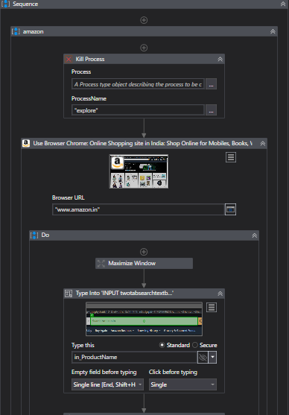

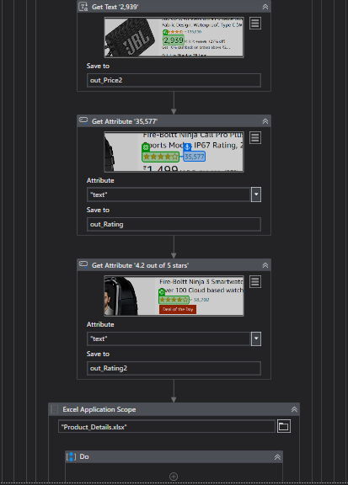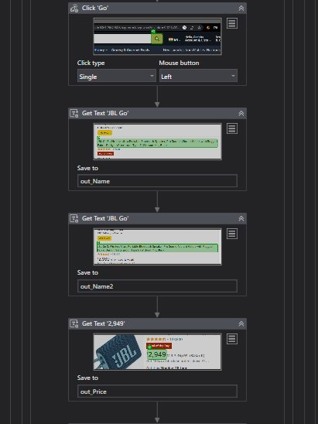

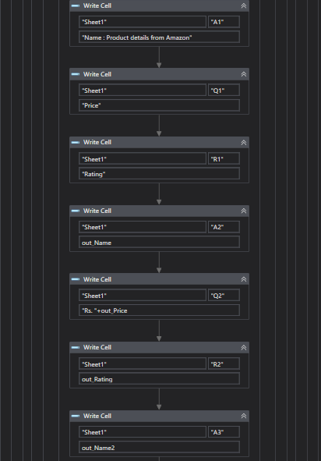

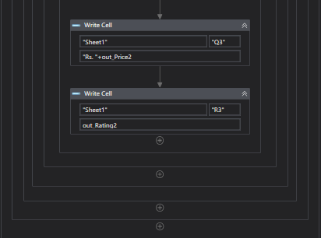

1. 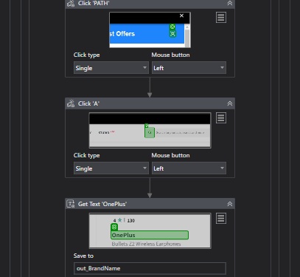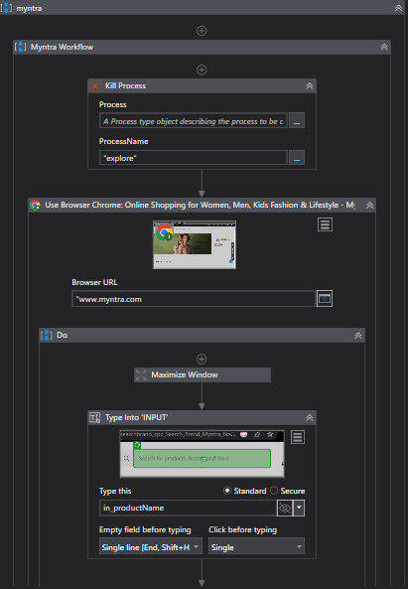**Myntra Sequence:**

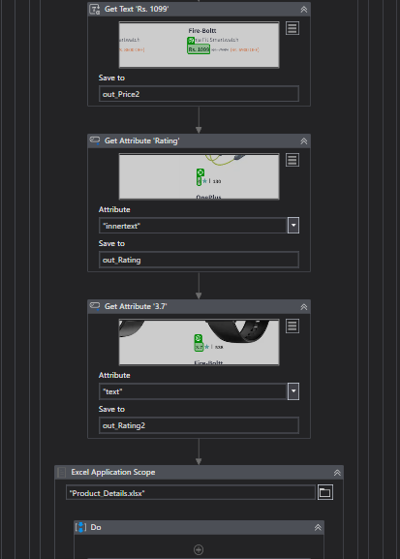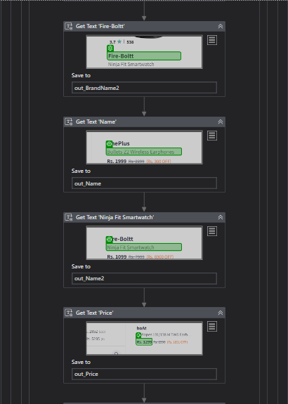

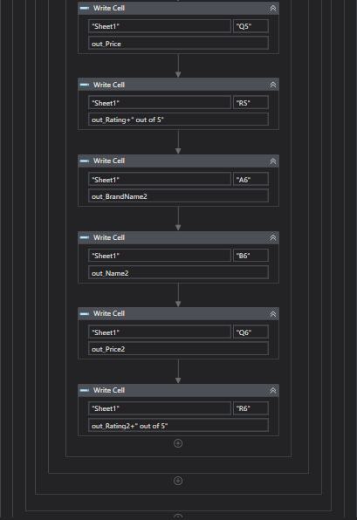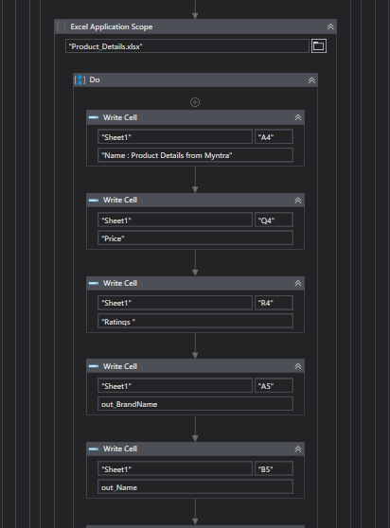

1. 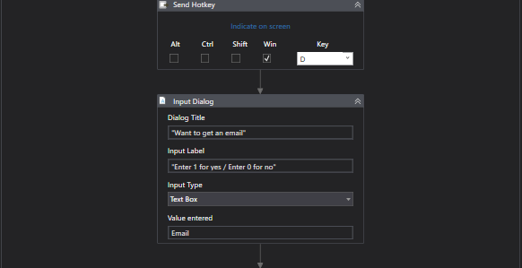**Compiled Project with Email 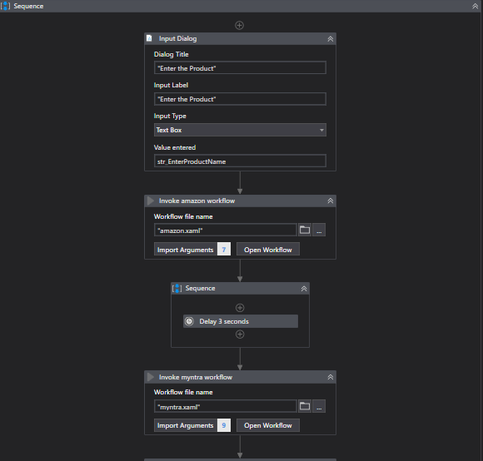Automation:**

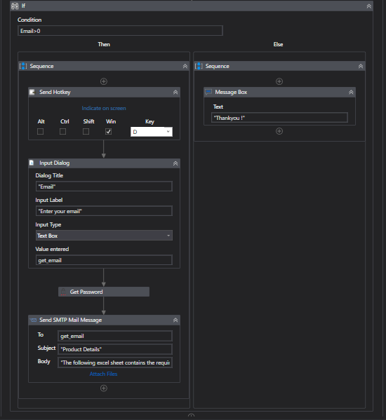

1. **Project outcome:**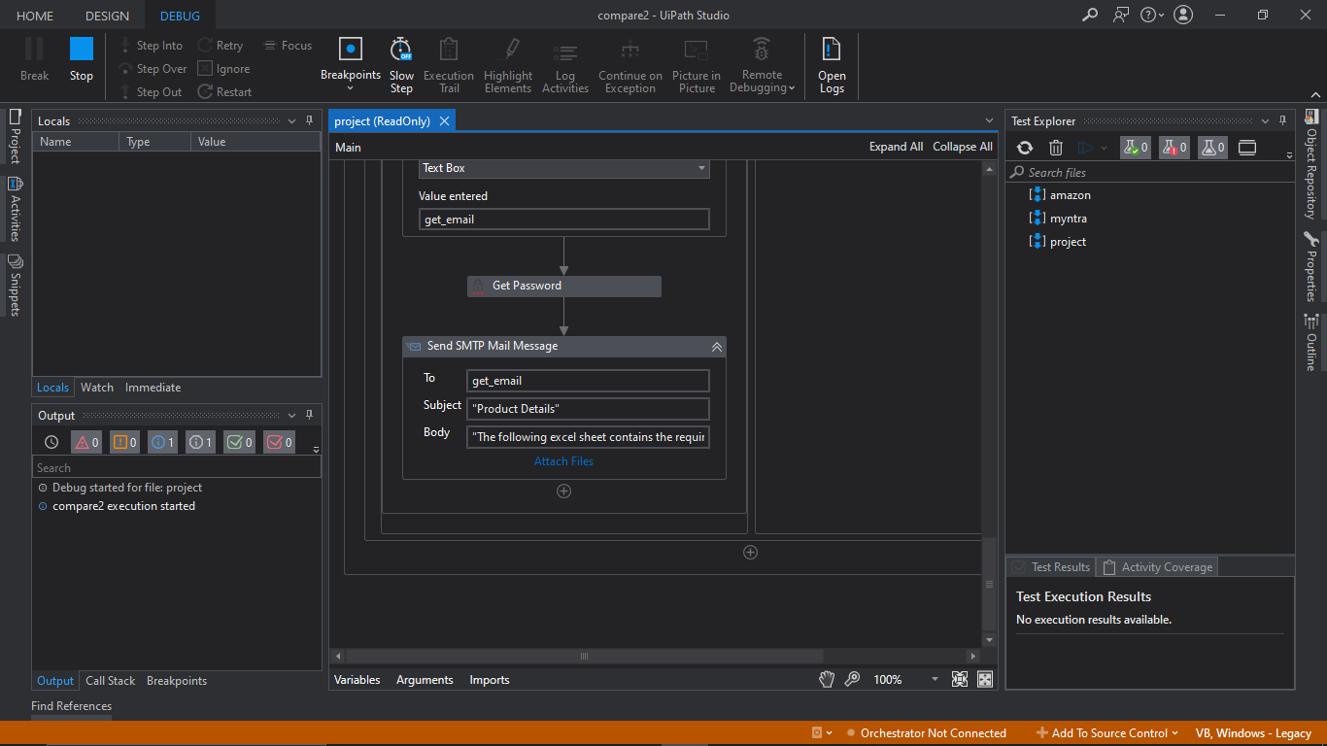

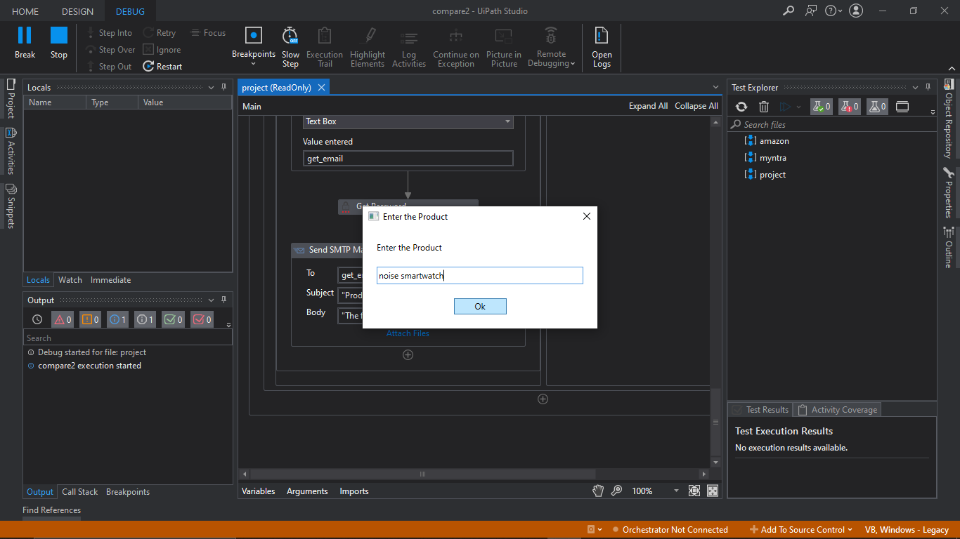

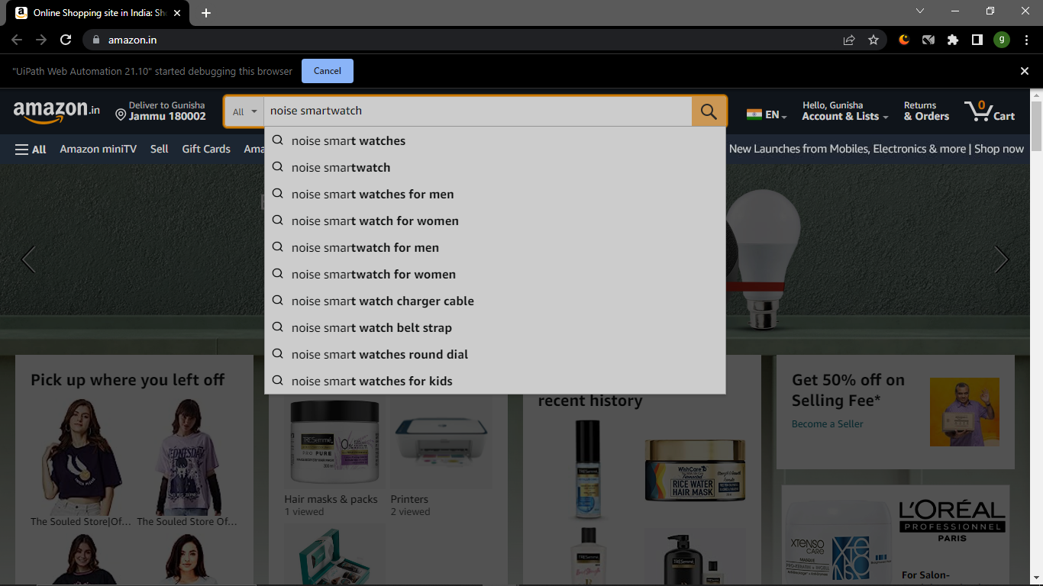

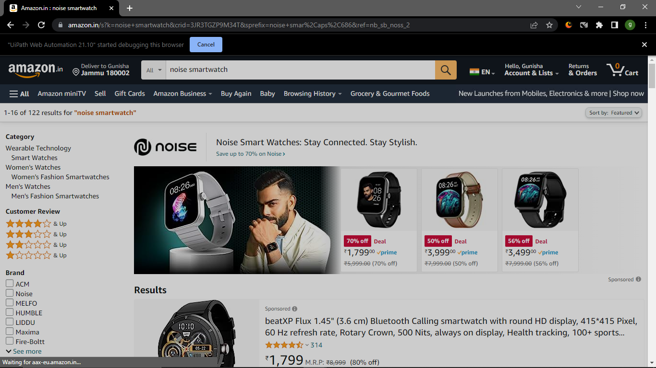

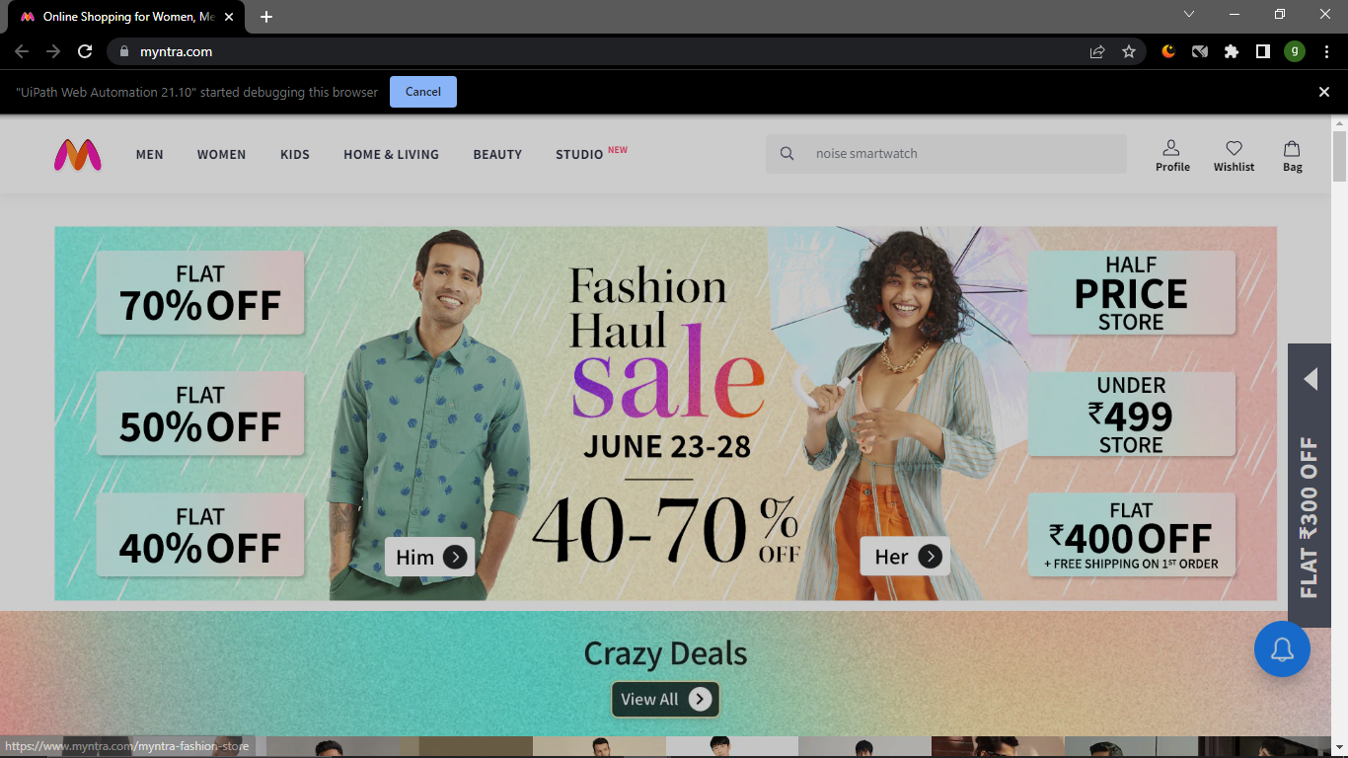

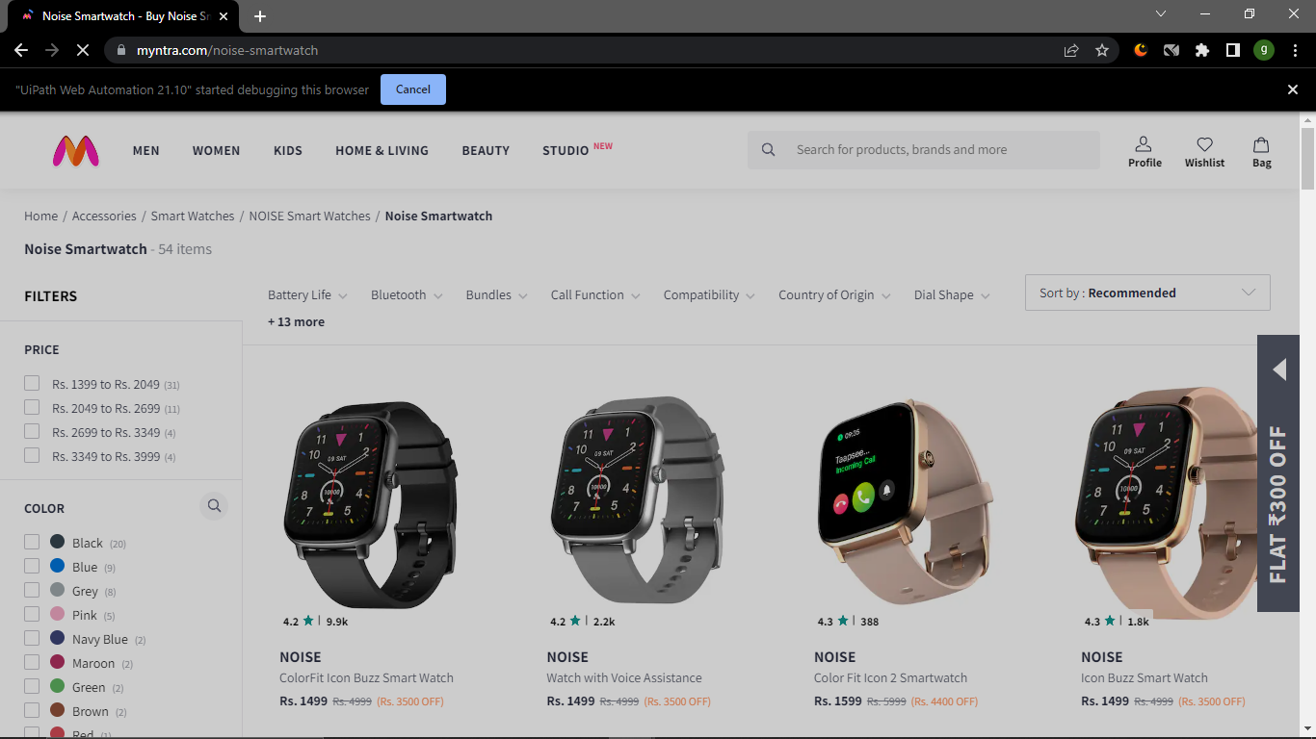

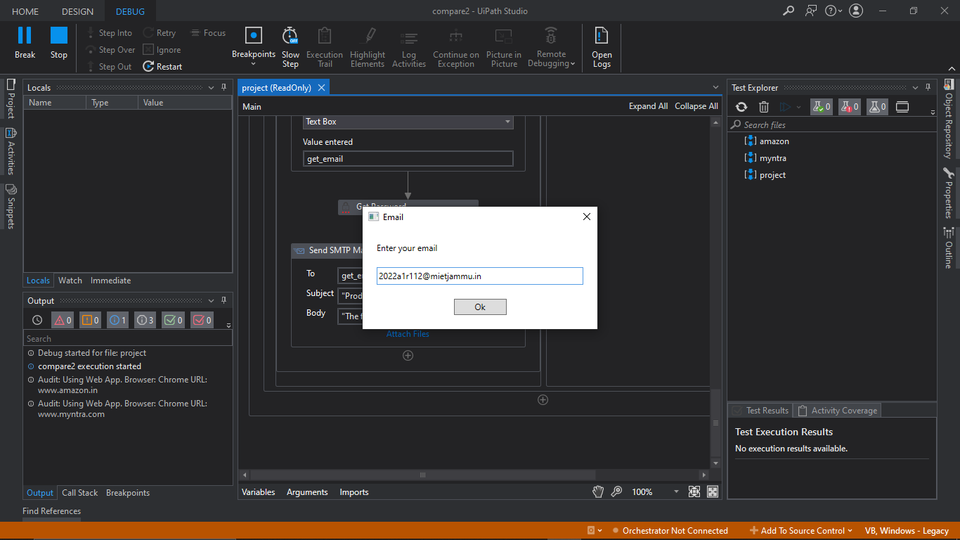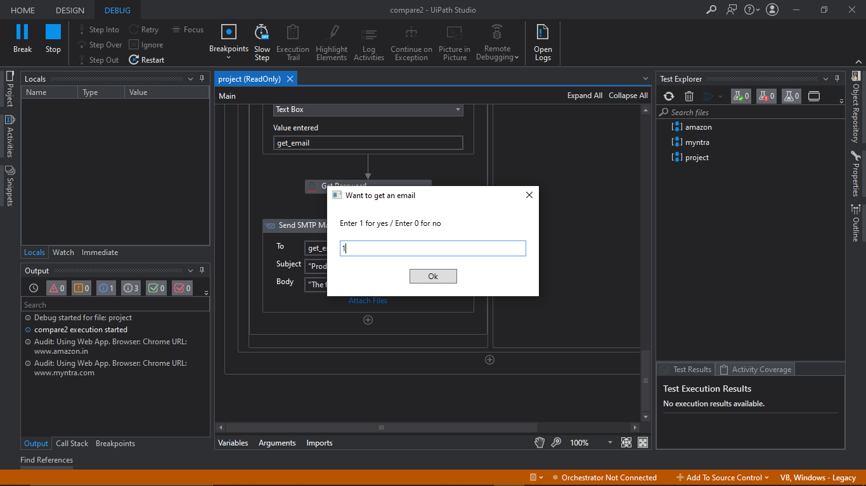

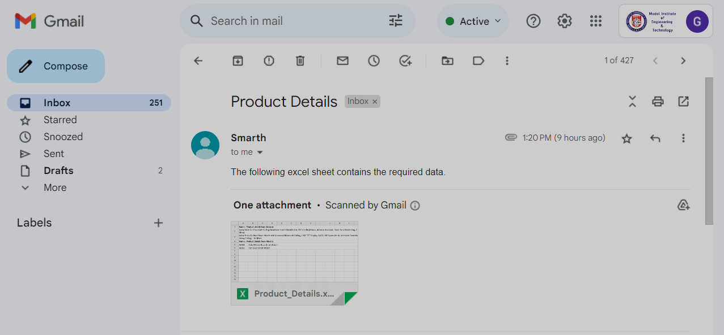

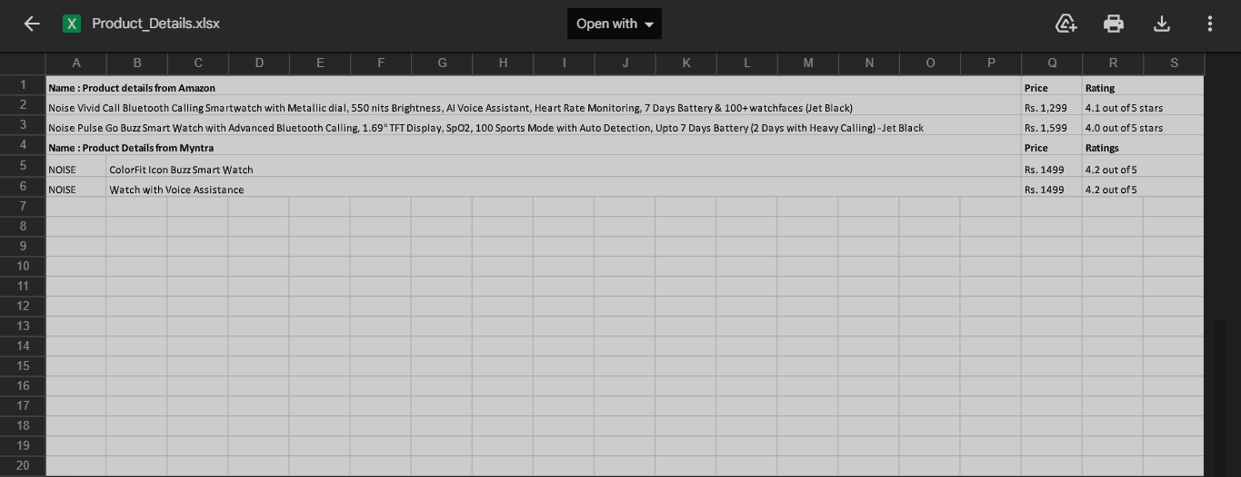



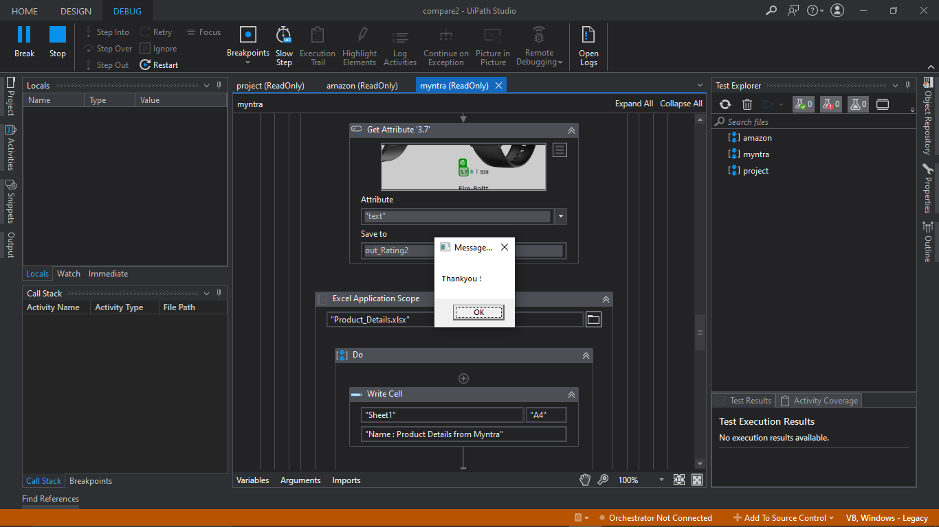

**Video Link To Our Project:**

<https://drive.google.com/drive/u/2/folders/1R9EiGWgSGu9DcFh5U1WnHlmaPmuroMnl>

**FLOWCHART**

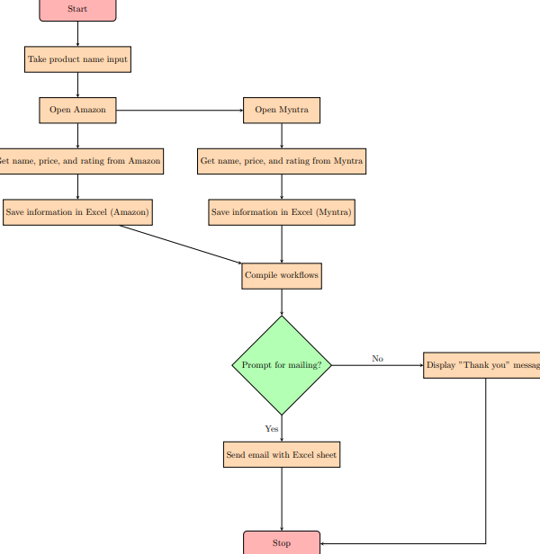**CONCLUSION**

In conclusion, the ClickShop project, powered by UiPath, offers an exceptional online shopping experience by extracting detailed information from popular websites such as Amazon and Myntra. Through the modified "Get Text" activity, customers can input their product preferences, and the system accurately retrieves targeted data from these websites. The project provides customers with comprehensive details including product features, pricing, and ratings, enabling them to make informed decisions.

In addition to the Excel sheet output, ClickShop goes a step further by offering an email feature. Customers have the option to receive personalized email notifications containing the complete product details, pricing information and Ratings. This email feature ensures that customers stay updated on their desired products and can easily access the necessary information right in their inbox.

With its integration of Amazon and Myntra, ClickShop becomes a valuable tool for customers seeking a comprehensive overview of top products from these popular platforms. The combination of accurate data extraction, Excel sheet generation, and the email feature makes ClickShop a powerful and convenient solution for online shoppers, streamlining their decision-making process and providing a seamless shopping experience.

**REFERENCE**

* Official UiPath documentation and tutorials: The UiPath website provides comprehensive documentation and tutorials on using UiPath Studio and its activities. It can serve as a valuable resource for understanding the "Get Text" activity and modifying selector settings.
* UiPath Forum: The UiPath community forum is a great place to seek advice and find relevant discussions related to web automation and data extraction techniques using UiPath. You can search for specific topics or post your questions to get insights from experienced users.
* Online tutorials and blogs: Explore online resources, such as blogs and tutorial websites, that cover topics related to web automation and data extraction with UiPath. Websites like UiPath Go!, Medium, and RPA Academy often have tutorials and articles that can provide insights and guidance for your project.
* Books on UiPath and RPA: Look for books specifically focused on UiPath and Robotic Process Automation (RPA). These books can offer in-depth knowledge on UiPath's capabilities, web automation, and data extraction techniques.